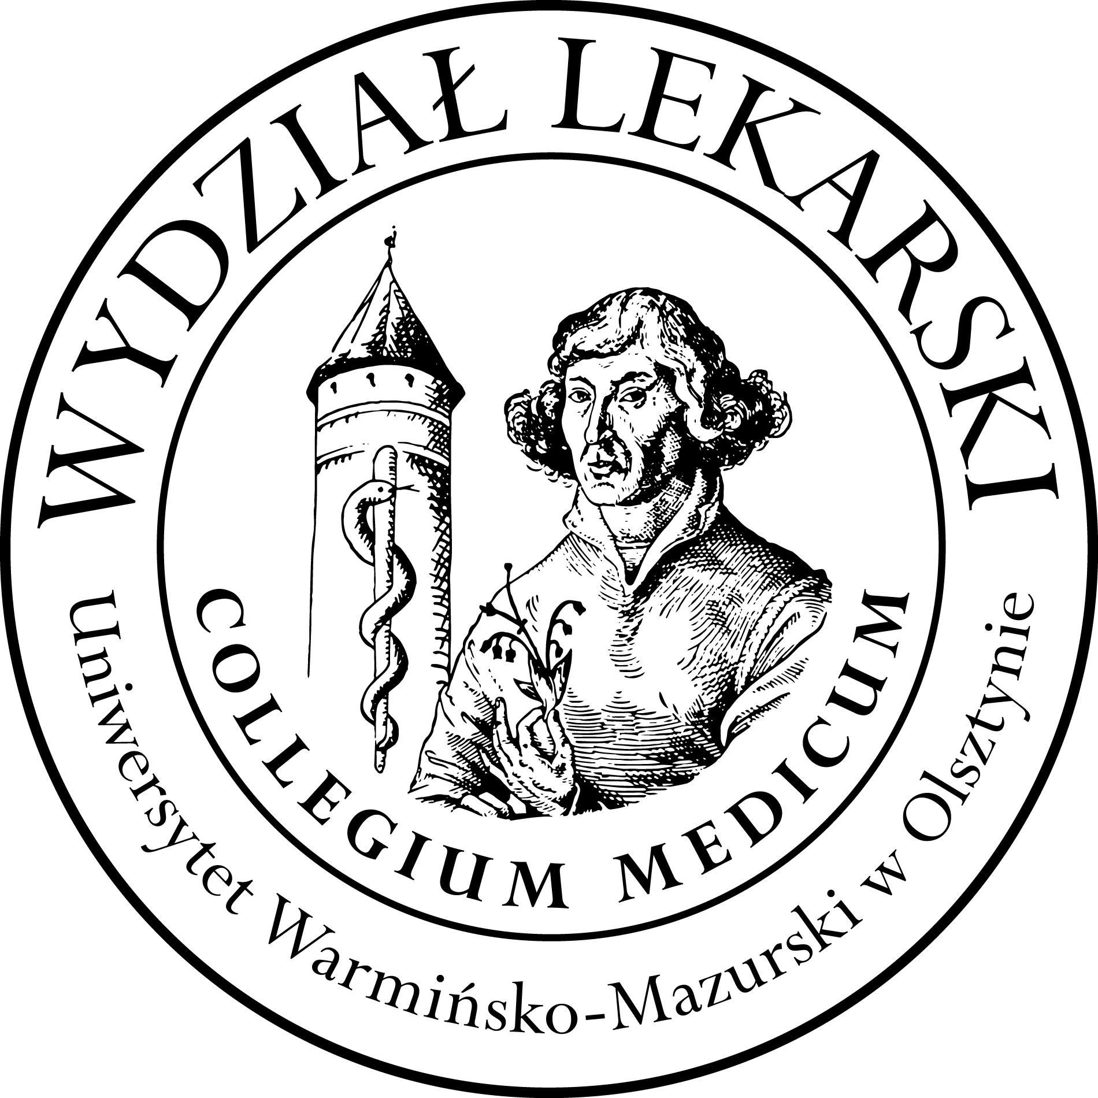

UNIVERSITY OF WARMIA AND MASURIA
in Olsztyn
COLLEGIUM MEDICUM
FACULTY OF MEDICINE
Warszawska 30, 10-082 Olsztyn, Poland
Tel.: +48 89 524 61 01∙ Fax.: +48 89 524 61 14
E-mail: medicine.info@uwm.edu.pl
studyingmedicine@gmail.com

PBL ( Problem Based Learning)

4 year ED – Winter - 2026/2027

Classes (12h) x 2 groups =24h dr n. med. Maciej Żechowicz

Group | Date | Time | Room
Gr. 1 | 28.10.26 | 13.00-15-45 | CSM 100D
Gr. 1 | 30.11.26 | 13.00-15-45 | CSM 100 D
Gr. 1 | 09.12.26 | 10.00-12.45 | CSM Lecture Hall
Gr. 1 | 09.12.26 | 13.00-15-45 | CSM Lecture Hall
Gr.2 | 09.11.26 | 13.00-15-45 | CSM 100D
Gr.2 | 16.11.26 | 13.00-15-45 | CSM 100D
Gr.2 | 25.11.26 | 13.00-15-45 | CSM 100D
Gr.2 | 21.12.26 | 13.00-15-45 | CSM 106

