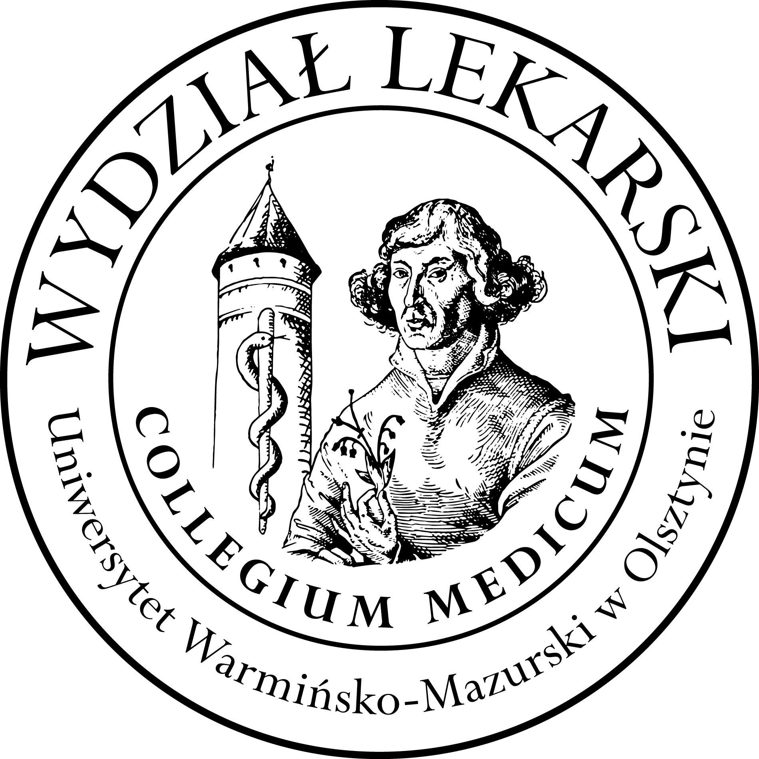

UNIVERSITY OF WARMIA AND MASURIA
in Olsztyn
COLLEGIUM MEDICUM
FACULTY OF MEDICINE
Warszawska 30, 10-082 Olsztyn, Poland
Tel.: +48 89 524 61 01∙ Fax.: +48 89 524 61 14
E-mail: medicine.info@uwm.edu.pl
studyingmedicine@gmail.com

PBL ( Problem Based Learning)

3 year ED – Winter - 2026/2027

Classes (12h) x 3 groups = 36h Dr n. med. Beata Moczulska ( BM )

Group | Date | Time |  | Room
Gr. 1  (BM) | 06.10.26 | 12.00-13.30 |  | Department of Internal Medicine, Conference Room USK Hospital  (next to the emergency room)  floor 3
Gr. 1  (BM) | 08.10.26 | 12.00-13.30
Gr. 1  (BM) | 13.10.26 | 12.00-13.30
Gr. 1  (BM) | 02.12.26 | 12.30-14.00
Gr. 1  (BM) | 17.12.26 | 12.00-13.30
Gr. 1  (BM) | 28.01.27 | 12.00-13.30
Gr.2  (BM) | 18.11.26 | 12.00-13.30
Gr.2  (BM) | 19.11.26 | 12.00-13.30
Gr.2  (BM) | 26.11.26 | 12.00-13.30
Gr.2  (BM) | 16.12.26 | 12.00-13.30
Gr.2  (BM) | 13.01.26 | 12.00-13.30
Gr.2  (BM) | 21.01.27 | 12.00-13.30
Gr.3  (BM) | 20.10.26 |  | 12.00-13.30
Gr.3  (BM) | 22.10.26 |  | 12.00-13.30
Gr.3  (BM) | 04.11.26 |  | 12.00-13.30
Gr.3  (BM) | 25.11.26 |  | 12.00-13.30
Gr.3  (BM) | 14.01.27 |  | 12.00-13.30
Gr.3  (BM) | 27.01.27 |  | 12.00-13.30

