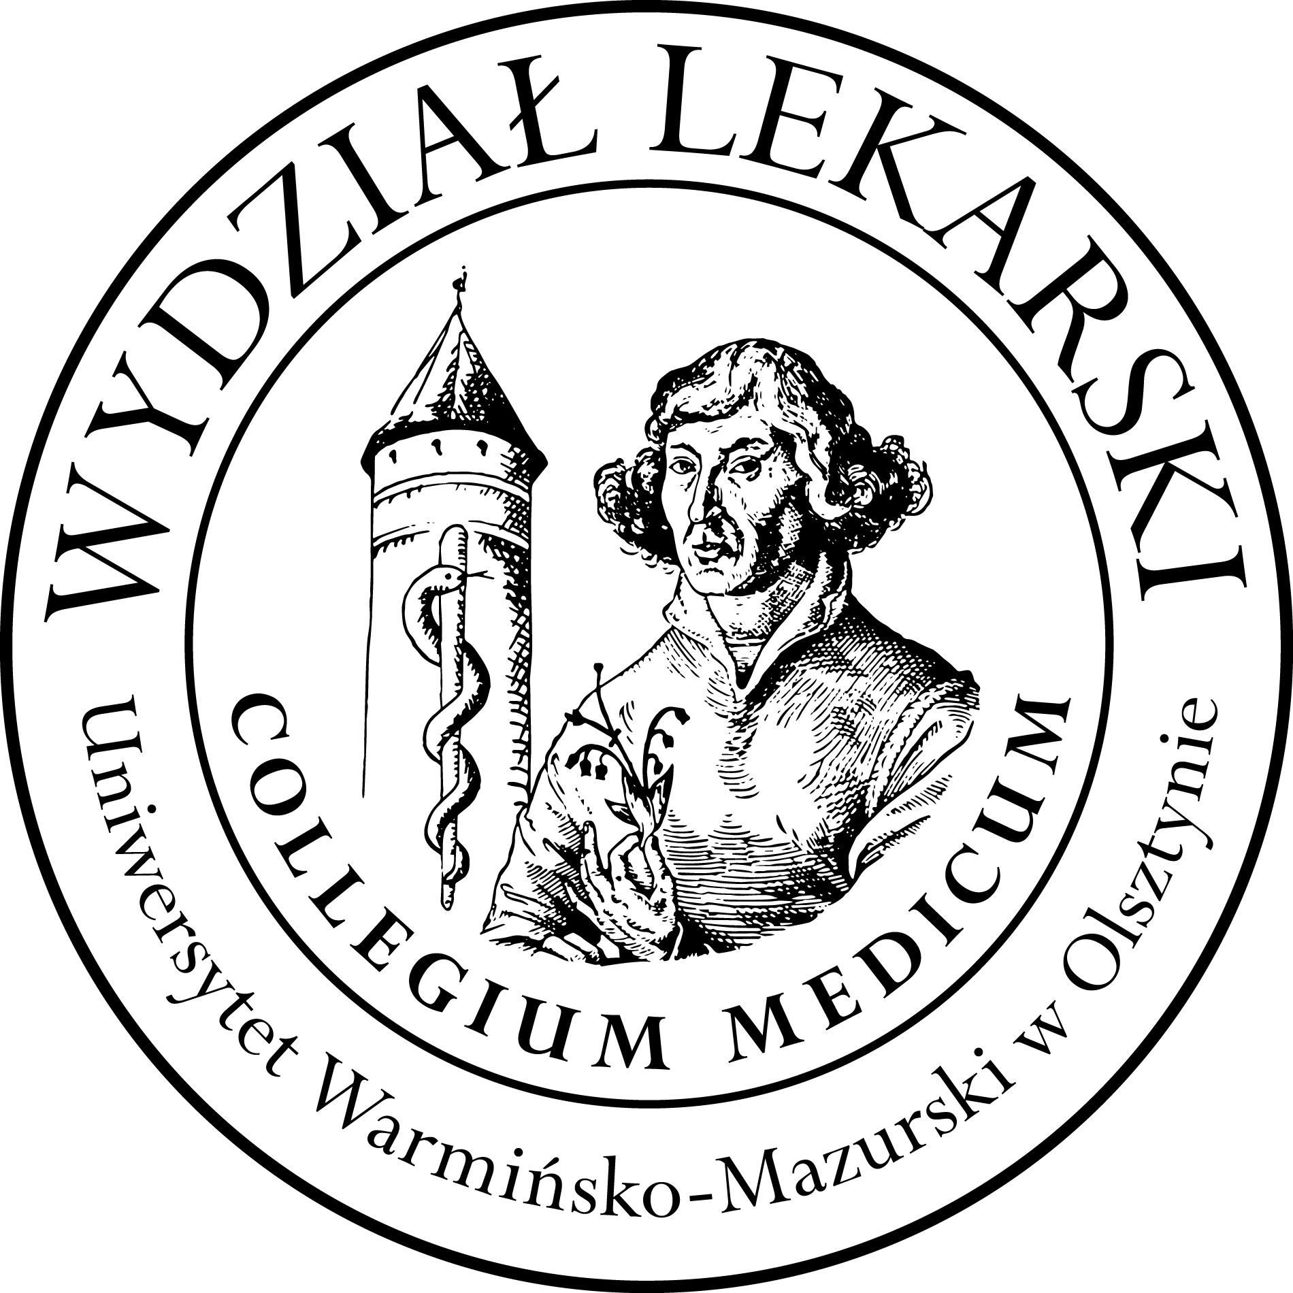

UNIVERSITY OF WARMIA AND MASURIA
in Olsztyn
COLLEGIUM MEDICUM
FACULTY OF MEDICINE
Warszawska 30, 10-082 Olsztyn, Poland
Tel.: +48 89 524 61 01∙ Fax.: +48 89 524 61 14
E-mail: medicine.info@uwm.edu.pl
studyingmedicine@gmail.com

Clinical Skills
3 year ED – Winter - 2026/2027

Classes (9h)-x 3gr=27h ----------------------------------------------------------------------------------------------------------------
Coordinator : dr n. med. Beata Moczulska
lek. med. Patryk Zastawny

Group | Date | Time | Room
1 | 10.11.26 | 14.30-16.45 | CSM Operating theatre
1 | 15.12.26 | 17.15-19.30 | CSM 206
1 | 14.01.27 | 14.45-17.00 | CSM 204
2 | 10.11.26 | 17.00-19.15 | CSM Operating theatre
2 | 19.11.26 | 14.30-16.45 | CSM 206
2 | 01.12.26 | 14.30-16.45 | CSM 206
3 | 19.11.26 | 17.00-19.15 | CSM Operating theatre
3 | 15.12.26 | 14.45-17.00 | CSM 206
3 | 14.01.27 | 17.15-19.30 | CSM 204

