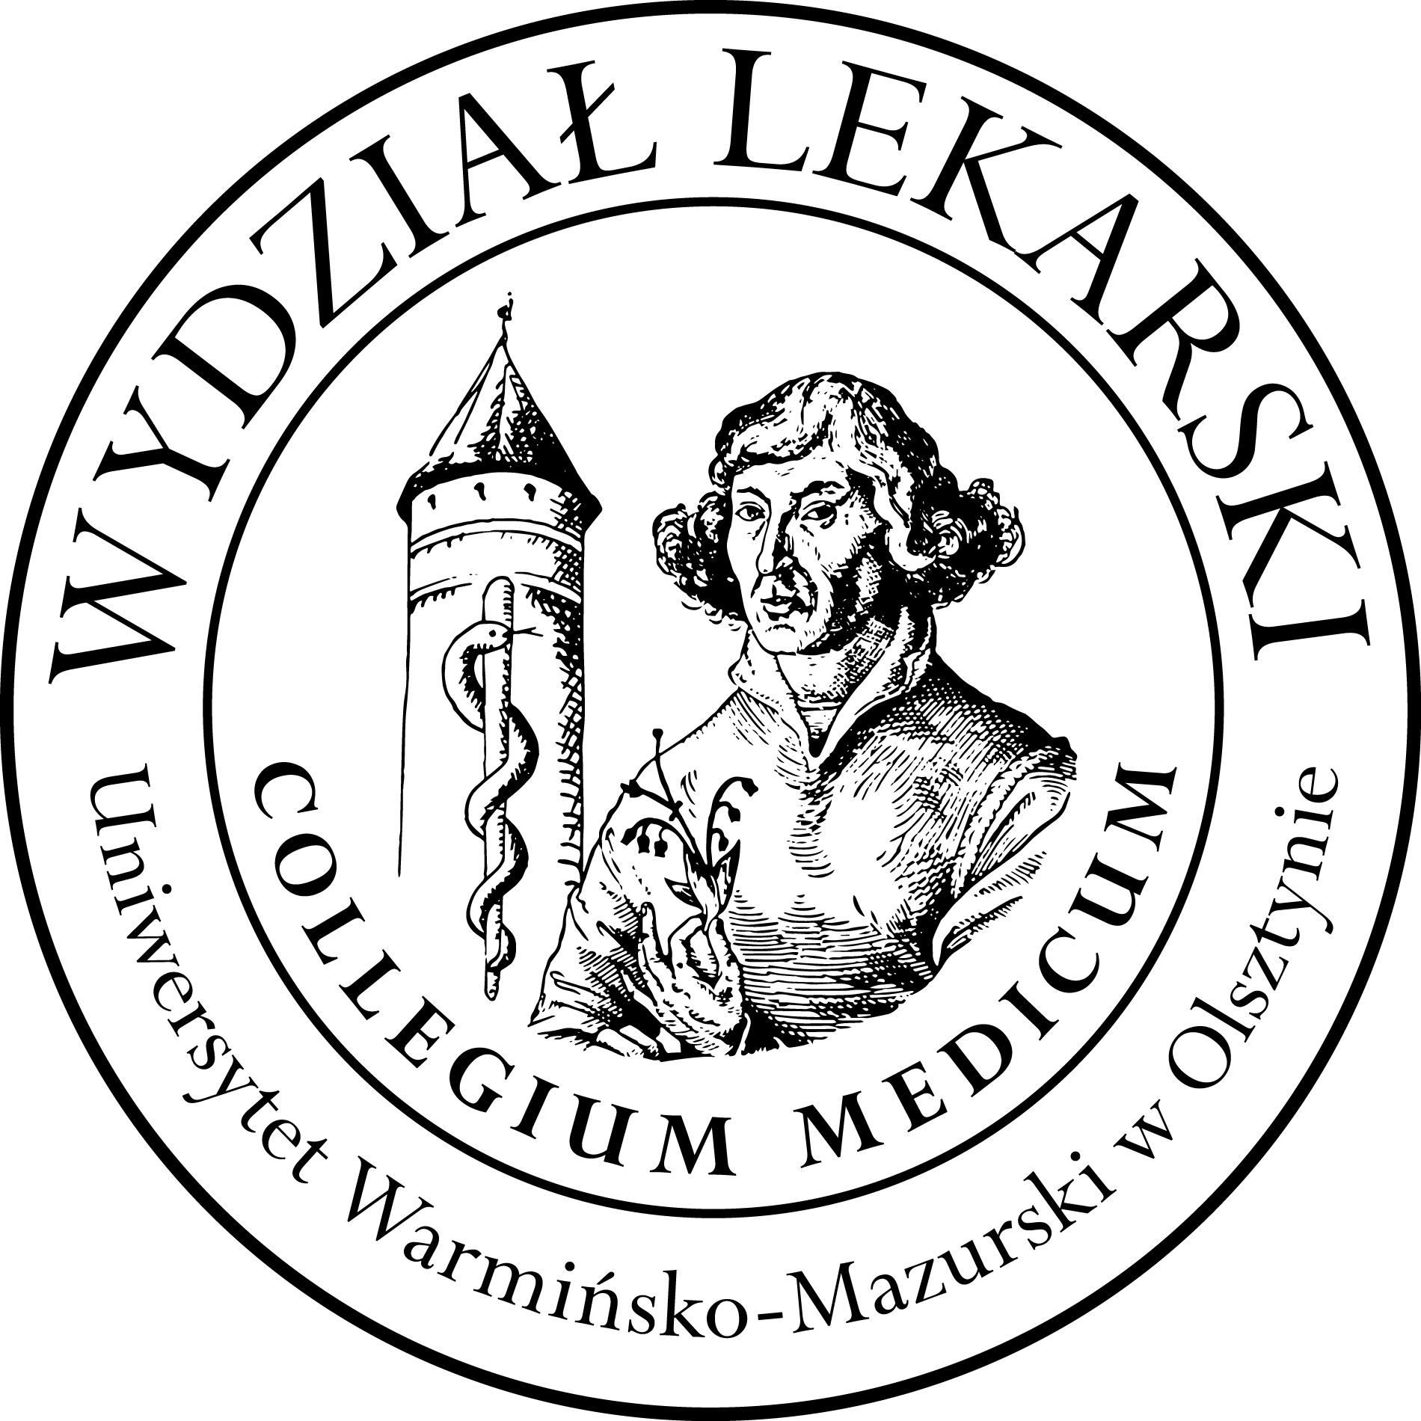

UNIVERSITY OF WARMIA AND MASURIA
in Olsztyn
COLLEGIUM MEDICUM
FACULTY OF MEDICINE
Warszawska 30, 10-082 Olsztyn, Poland
Tel.: +48 89 524 53 89∙ Fax.: +48 89 524 53 89
E-mail: barbara.neumann@uwm.edu.pl
studyingmedicine@gmail.com

Schedules Nuclear Medicine III ED 2025/2026
Prof. Jarosław Ćwikła MD, PhD

Lectures: CSM 100 D
18.03.26 CSM Lecture Hall, 13.15-14.45
25.03.26 Behring Center 307, 9.45-11.15
22.04.26 CSM 100D, 12.00 -13.30
27.05.26 Library 116, 16.00-17.30
10.06.26 CSM 100D, 13.15-14.45

Classes :
Gr 1
22.04.26 100D, 13.45-15.45
10.06.26 100D, 11.00-13.00
Gr 2
27.05.26 Library 116, 12.00-14.00
18.03.26 CSM Lecture Hall, 11.00-13.00

