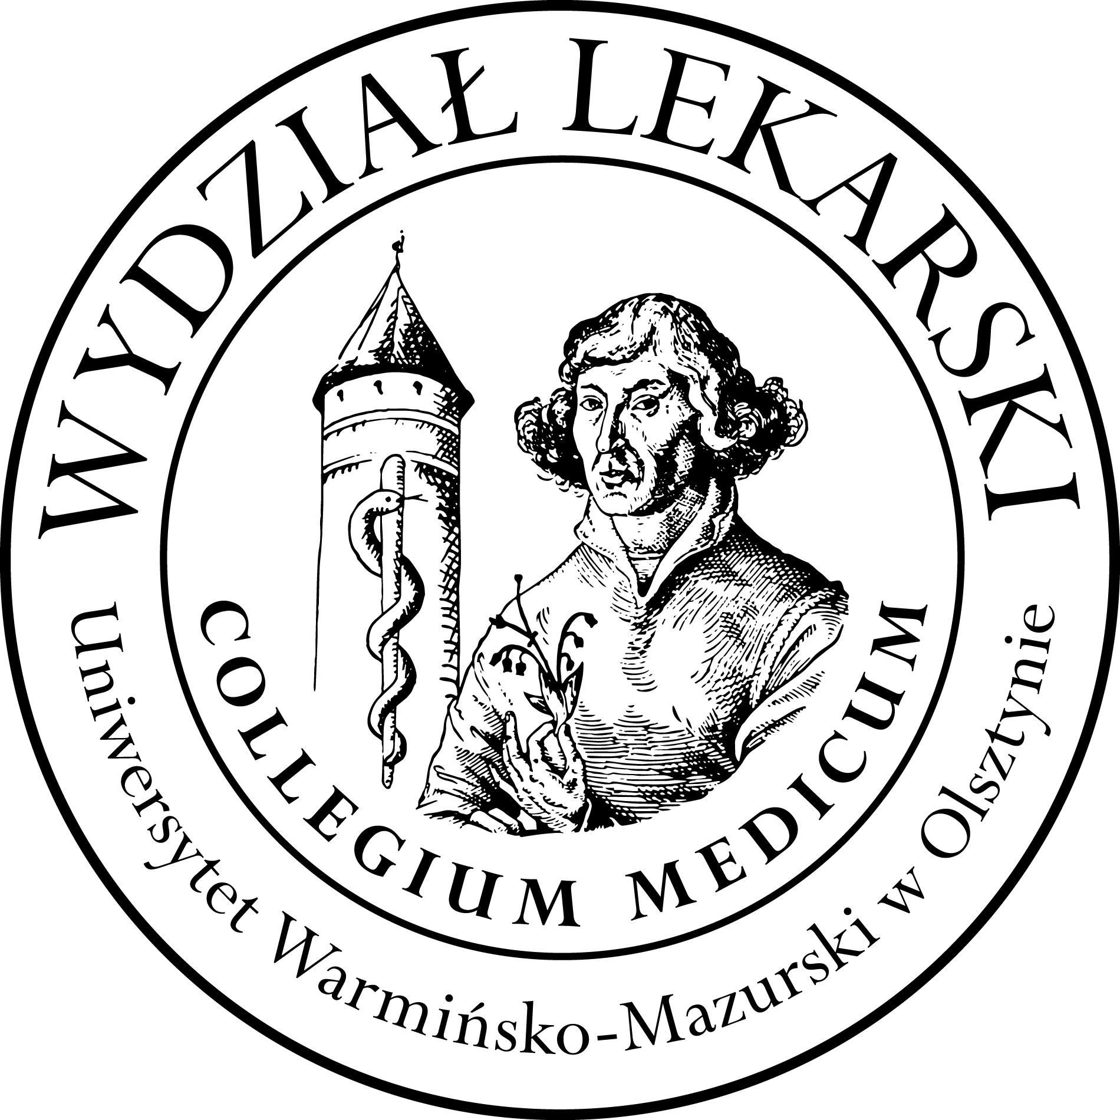

UNIVERSITY OF WARMIA AND MASURIA
in Olsztyn
COLLEGIUM MEDICUM
FACULTY OF MEDICINE
Warszawska 30, 10-082 Olsztyn, Poland
Tel.: +48 89 524 61 01∙ Fax.: +48 89 524 61 14
E-mail: medicine.info@uwm.edu.pl
studyingmedicine@gmail.com

PBL ( Problem Based Learning)

3 year ED – summer- 2025/2026

Classes (12h) x 2 groups =24h Dr n. med. Beata Moczulska ( BM )

Group | Date | Time | Room
Gr. 1  (BM) | 26.02.26 | 13.15-14.45 | Department of Internal Medicine, Conference Room USK Hospital  (next to the emergency room)  floor 3
Gr. 1  (BM) | 06.03.26 | 12.00-13.30
Gr. 1  (BM) | 24.03.26 | 12.00-13.30
Gr. 1  (BM) | 21.04.26 | 12.00-13.30
Gr. 1  (BM) | 05.05.26 | 12.00-13.30
Gr. 1  (BM) | 12.05.26 | 12.00-13.30
Gr.2  (BM) | 10.03.26 | 12.00-13.30
Gr.2  (BM) | 13.03.26 | 12.15-13.45
Gr.2  (BM) | 17.03.26 | 12.00-13.30
Gr.2  (BM) | 27.03.26 | 12.00-13.30
Gr.2  (BM) | 31.03.26 | 12.00-13.30
Gr.2  (BM) | 14.04.26 | 12.00-13.30

