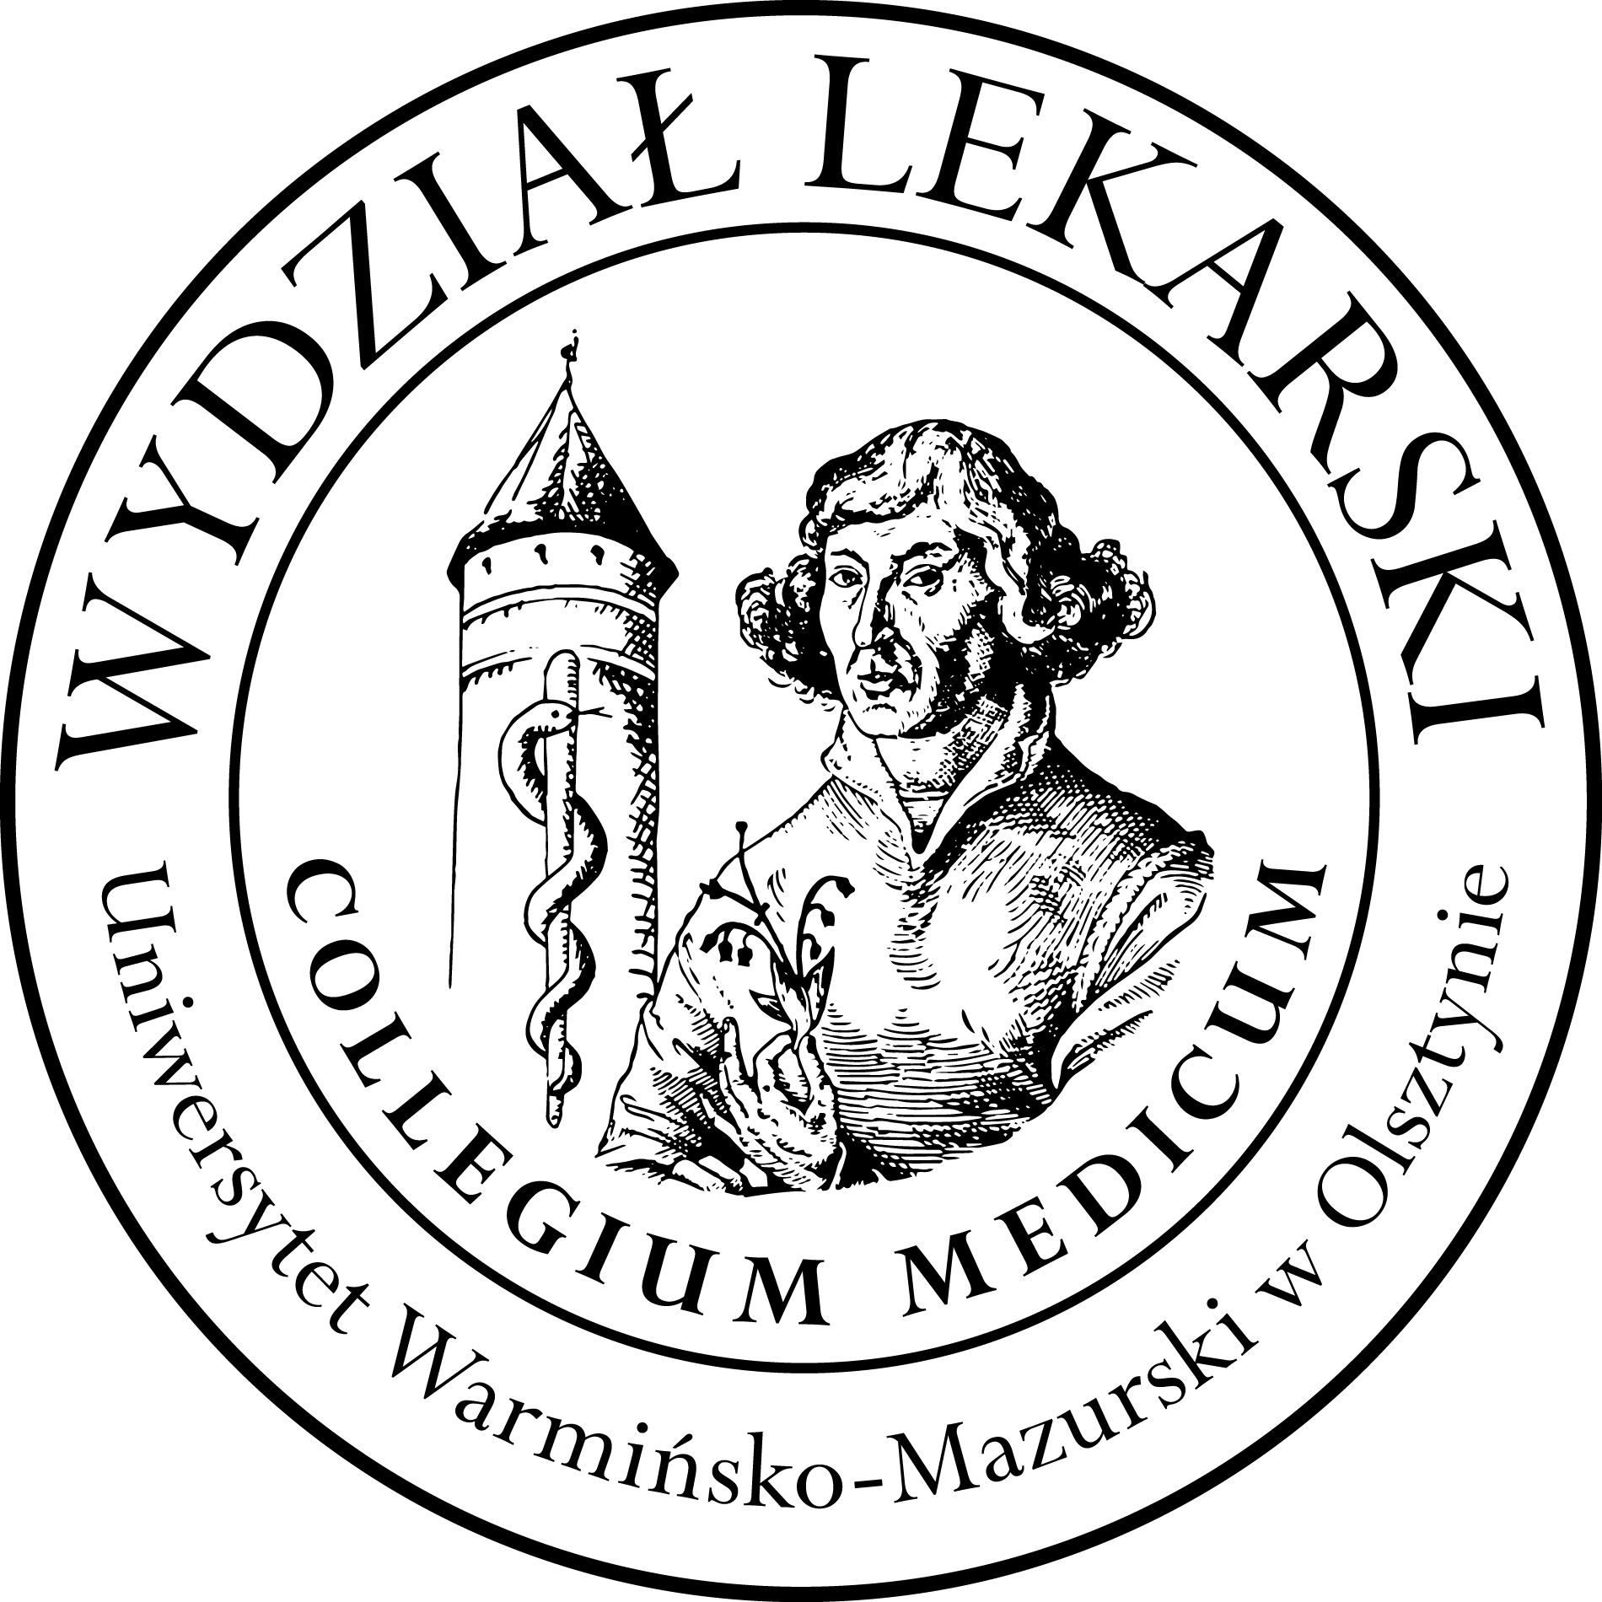

UNIVERSITY OF WARMIA AND MASURIA
in Olsztyn
COLLEGIUM MEDICUM
FACULTY OF MEDICINE
Warszawska 30, 10-082 Olsztyn, Poland
Tel.: +48 89 524 61 01∙ Fax.: +48 89 524 61 14
E-mail: medicine.info@uwm.edu.pl

studyingmedicine@gmail.com

Clinical skills
2 year ED – Summer - 2025/2026
Coordinator: Beata Moczulska MD PhD
Teatcher : Patryk Zastawny MD

Classes (15h) x 4 groups= 60 h x 2,5 = 150h

Group | Date | Time | Room
Gr. 1 | 16.04.26 | 17.30-19.45 | CSM 206
Gr. 1 | 23.04.26 | 17.30-19.45 | CSM 206
Gr. 1 | 30.04.26 | 17.30-19.45 | CSM 206
Gr. 1 | 07.05.26 | 17.30-19.45 | CSM 206
Gr. 1 | 14.05.26 | 17.30-19.45 | CSM 206
Gr. 2 | 16.04.26 | 15.00-17.15 | CSM 206
Gr. 2 | 23.04.26 | 15.00-17.15 | CSM 206
Gr. 2 | 30.04.26 | 15.00-17.15 | CSM 206
Gr. 2 | 07.05.26 | 15.00-17.15 | CSM 206
Gr. 2 | 14.05.26 | 15.00-17.15 | CSM 206
Gr. 3 | 14.04.26 | 15.00-17.15 | CSM 206
Gr. 3 | 21.04.26 | 15.00-17.15 | CSM 206
Gr. 3 | 28.04.26 | 15.00-17.15 | CSM 206
Gr. 3 | 05.05.26 | 15.00-17.15 | CSM 206
Gr. 3 | 12.05.26 | 15.00-17.15 | CSM 206
Gr. 4 | 14.04.26 | 17.30-19.45 | CSM 206
Gr. 4 | 21.04.26 | 17.30-19.45 | CSM 206
Gr. 4 | 28.04.26 | 17.30-19.45 | CSM 206
Gr. 4 | 05.05.26 | 17.30-19.45 | CSM 206
Gr. 4 | 12.05.26 | 17.30-19.45 | CSM 206

