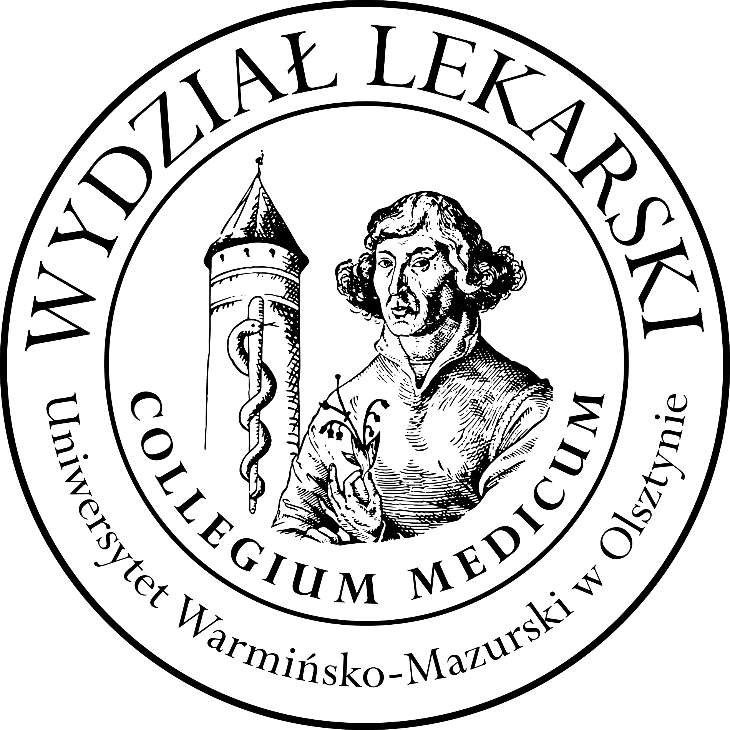

**UNIVERSITY OF WARMIA AND MASURIA**

in Olsztyn

**COLLEGIUM MEDICUM**

**FACULTY OF MEDICINE**

Warszawska 30, 10-082 Olsztyn, Poland

Tel.: +48 89 524 61 01∙ Fax.: +48 89 524 61 14

E-mail: medicine.info@uwm.edu.pl

studyingmedicine@gmail.com

**PBL ( Problem Based Learning)**

**3 year ED – Winter - 2025/2026**

**Classes (12h) x 2groups =24h *Dr n. med. Beata Moczulska ( BM )***

|  |  |  |  |
| --- | --- | --- | --- |
| ***Group*** | ***Date*** | ***Time*** | ***Room*** |
| ***Gr. 1***  ***(BM)*** | ***14.10.25*** | ***12.00-13.30*** | ***Department of Internal Medicine, Conference Room USK Hospital***  ***(next to the emergency room)***  ***floor 3*** |
| ***17.10.25*** | ***12.00-13.30*** |
| ***07.11.25*** | ***12.00-13.30*** |
| ***21.11.25*** | ***12.30-14.00*** |
| ***25.11.25*** | ***12.00-13.30*** |
| ***19.12.25*** | ***12.00-13.30*** |
|  | |
| ***Gr.2***  ***(BM)*** | ***07.10.25*** | ***12.00-13.30*** |
| ***28.10.25*** | ***12.00-13.30*** |
| ***04.11.25*** | ***12.00-13.30*** |
| ***18.11.25*** | ***12.00-13.30*** |
| ***16.12.25*** | ***12.00-13.30*** |
| ***13.01.26*** | ***12.00-13.30*** |
|  | |