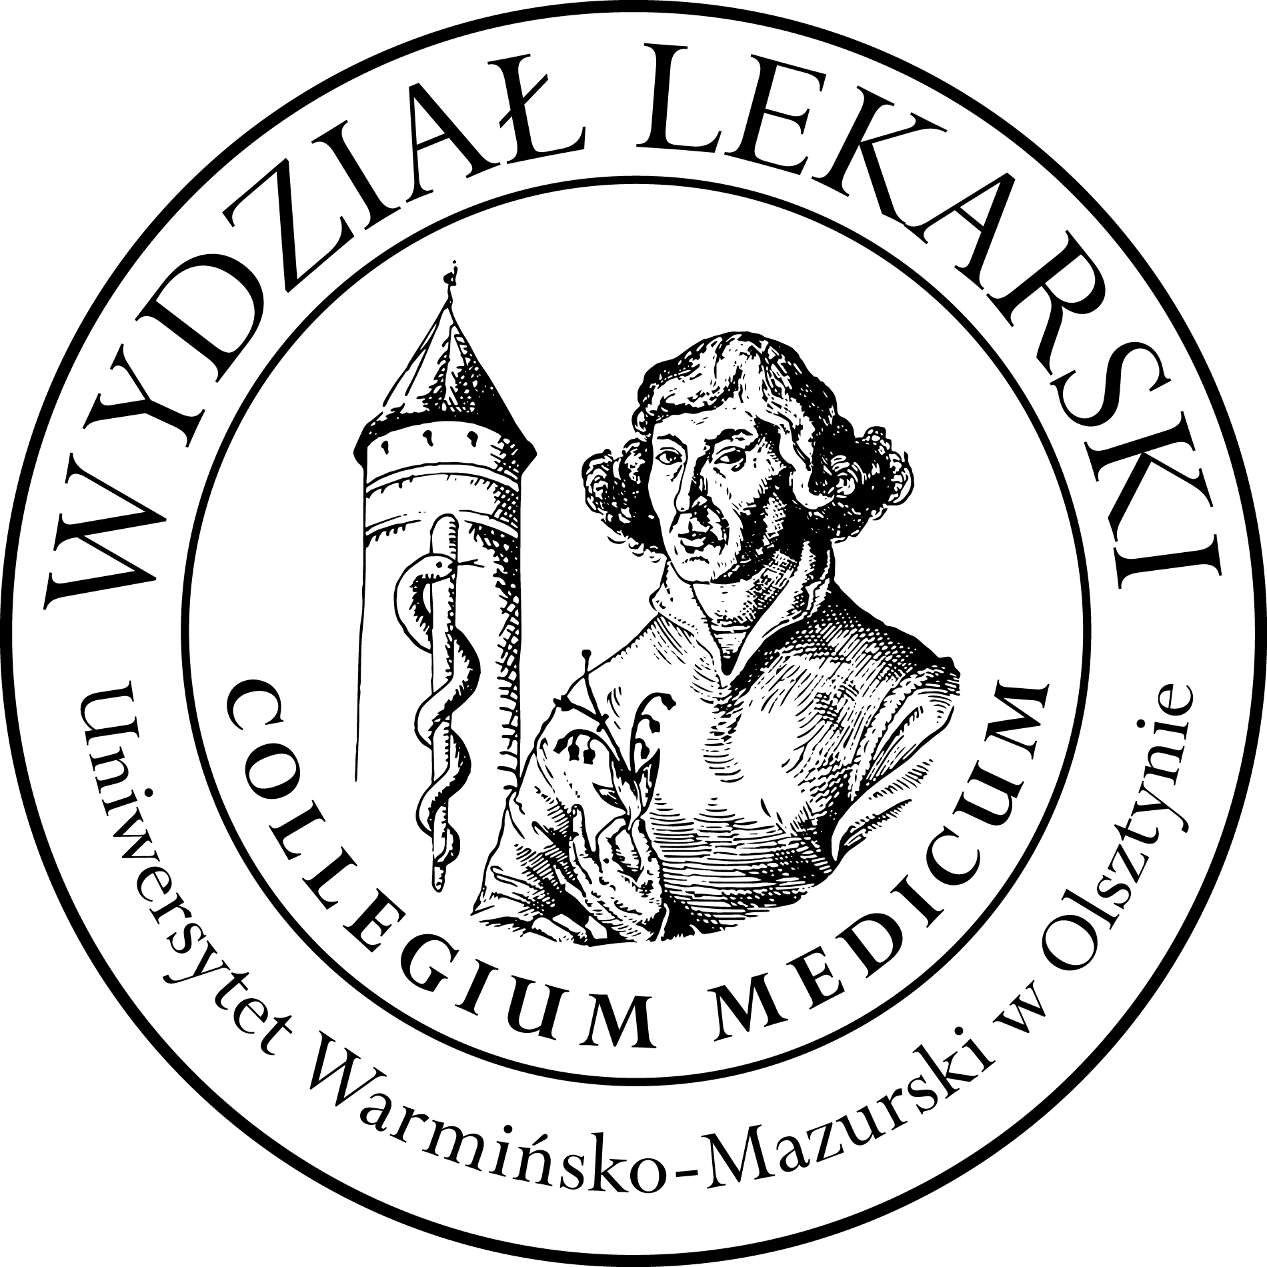

**UNIVERSITY OF WARMIA AND MASURIA**

in Olsztyn

**COLLEGIUM MEDICUM**

**FACULTY OF MEDICINE**

Warszawska 30, 10-082 Olsztyn, Poland

Tel.: +48 89 524 53 89∙ Fax.: +48 89 524 53 89

E-mail: barbara.neumann@uwm.edu.pl

studyingmedicine@gmail.com

**Schedules Nuclear Medicine III ED 2024/2025**

**Prof. Jarosław Ćwikła MD, PhD**

**Lectures: CSM 100 D**

**30.04.25, 28.05.25 hour 12.00-13.30**

**21.05.25 hour 15.00-16.30**

**04.06, 11.06 hour 12.30 -14.00**

**Classes : CSM 100 D**

**Gr 1**

**04.06.25 hour 8.00-10.00**

**11.06.25 hour 8.00-10.00**

**Gr 2**

**28.05.25 hour 9.45-11.45**

**21.05.25 hour 12.45-14.45**

**Gr 3**

**04.06.25 hour 10.15-12.15**

**11.06.25 hour 10.15-12.15**