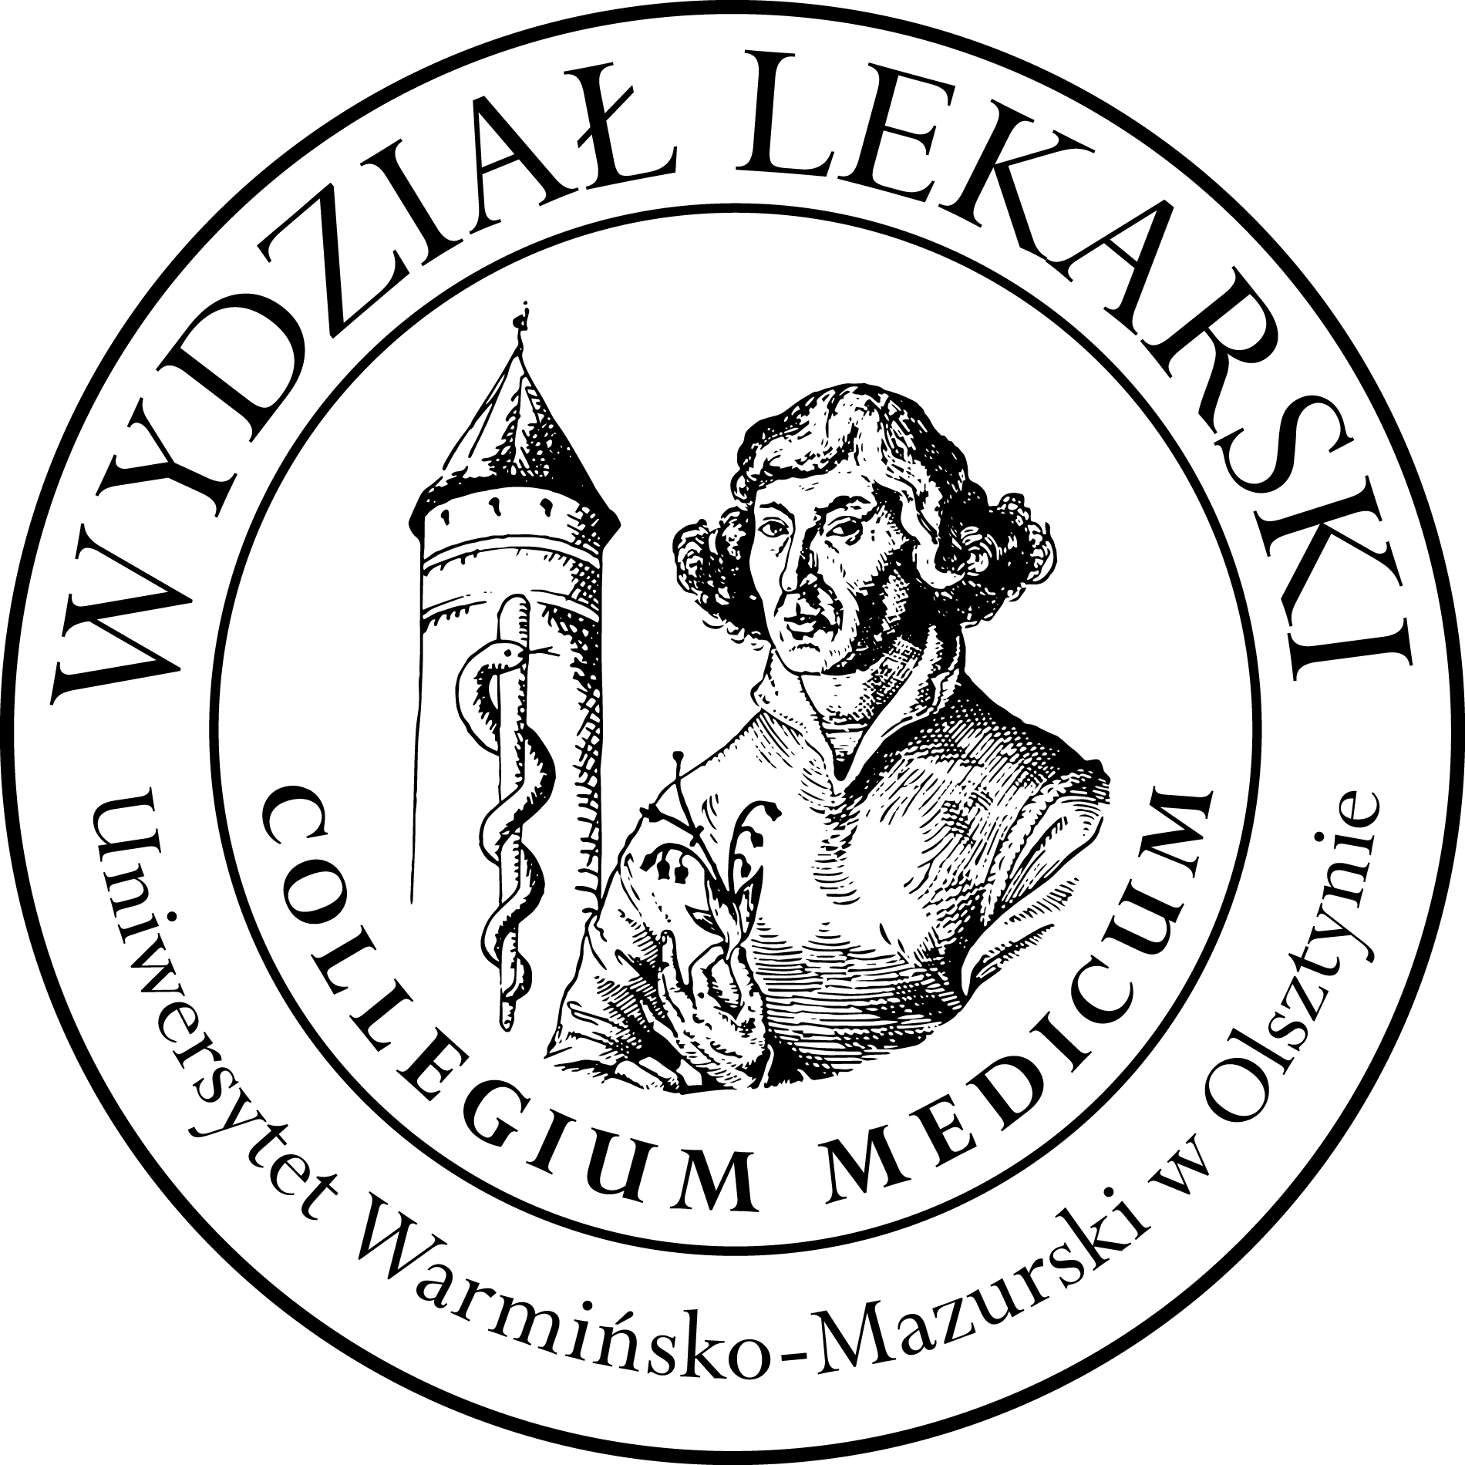

**UNIVERSITY OF WARMIA AND MASURIA**

in Olsztyn

**COLLEGIUM MEDICUM**

**FACULTY OF MEDICINE**

Warszawska 30, 10-082 Olsztyn, Poland

Tel.: +48 89 524 61 01∙ Fax.: +48 89 524 61 14

E-mail: medicine.info@uwm.edu.pl

studyingmedicine@gmail.com

**PBL ( Problem Based Learning)**

**3 year ED – Summer - 2024/2025**

**Classes (20h) x3 groups =60h -------------------------------------------------------------------------------------------------------------------------------------**

***Course Coordinator dr n. med. Beata Moczulska ( BM)***

|  |  |  |  |
| --- | --- | --- | --- |
| ***Group*** | ***Date*** | ***Time*** | ***Room*** |
| ***1***  ***(BM)*** | ***18.03.25*** | ***12.00-13.30*** | ***Department of Internal Medicine, Conference Room USK Hospital***  ***(next to the emergency room)***  ***floor 3*** |
| ***19.03.25*** | ***12.00-14.15*** |
| ***21.03.25*** | ***12.15-13.45*** |
| ***29.04.25*** | ***12.00-14.15*** |
| ***06.05.25*** | ***12.30-14.00*** |
| ***20.05.25*** | ***12.00-14.15*** |
| ***27.05.25*** | ***12.00-13.30*** |
| ***09.06.25*** | ***11.00-13.15*** |
|  |  |
| ***2***  ***(BM)*** | ***11.03.25*** | ***12.00-13.30*** |
| ***14.03.25*** | ***12.00-14.15*** |
| ***01.04.25*** | ***12.30-14.00*** |
| ***08.04.25*** | ***12.30-14.45*** |
| ***15.04.25*** | ***12.00-13.30*** |
| ***23.04.25*** | ***12.00-14.15*** |
| ***06.06.25*** | ***11.45-13.15*** |
| ***10.06.25*** | ***12.30-14.45*** |
|  |  |
| ***3***  ***(BM)*** | ***04.03.25*** | ***12.00-13.30*** |
| ***25.03.25*** | ***12.00-14.15*** |
| ***08.05.25*** | ***12.00-13.30*** |
| ***13.05.25*** | ***12.30-14.45*** |
| ***22.05.25*** | ***12.00-13.30*** |
| ***03.06.25*** | ***11.00-13.15*** |
| ***10.06.25*** | ***11.00-12.30*** |
| ***13.06.25*** | ***11.00-13.15*** |
|  |  |