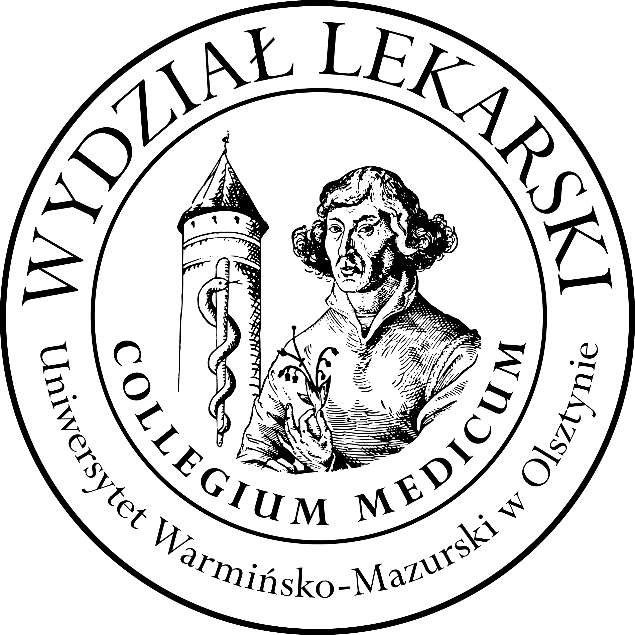

**UNIVERSITY OF WARMIA AND MASURIA**

in Olsztyn

**COLLEGIUM MEDICUM**

**FACULTY OF MEDICINE**

Warszawska 30, 10-082 Olsztyn, Poland

Tel.: +48 89 524 61 01∙ Fax.: +48 89 524 61 14

E-mail: [medicine.info@uwm.edu.pl](mailto:medicine.info@uwm.edu.pl)

studyingmedicine@gmail.com

**Clinical skills**

**2 year ED – Summer - 2024/2025**

**Coordinator Beata Moczulska MD PhD**

**Teatcher : Patryk Zastawny MD**

**Classes (15h) x 3 groups= 45 h x 3 = 135h**

|  |  |  |  |
| --- | --- | --- | --- |
| ***Group*** | ***Date*** | ***Time*** | ***Room*** |
| ***Gr. 1*** | **03.03.25** | **11.30-13.45** | ***CSM 102*** |
| **10.03.25** | ***CSM 206*** |
| **17.03.25** |
| **24.03.25** |
| **31.03.25** |
|  |  |  |  |
| ***Gr. 2*** | **26.02.25** | **8.45-11.00** | ***CSM 102*** |
| **05.03.25** |
| **12.03.25** |
| **26.03.25** |
| **02.04.25** |