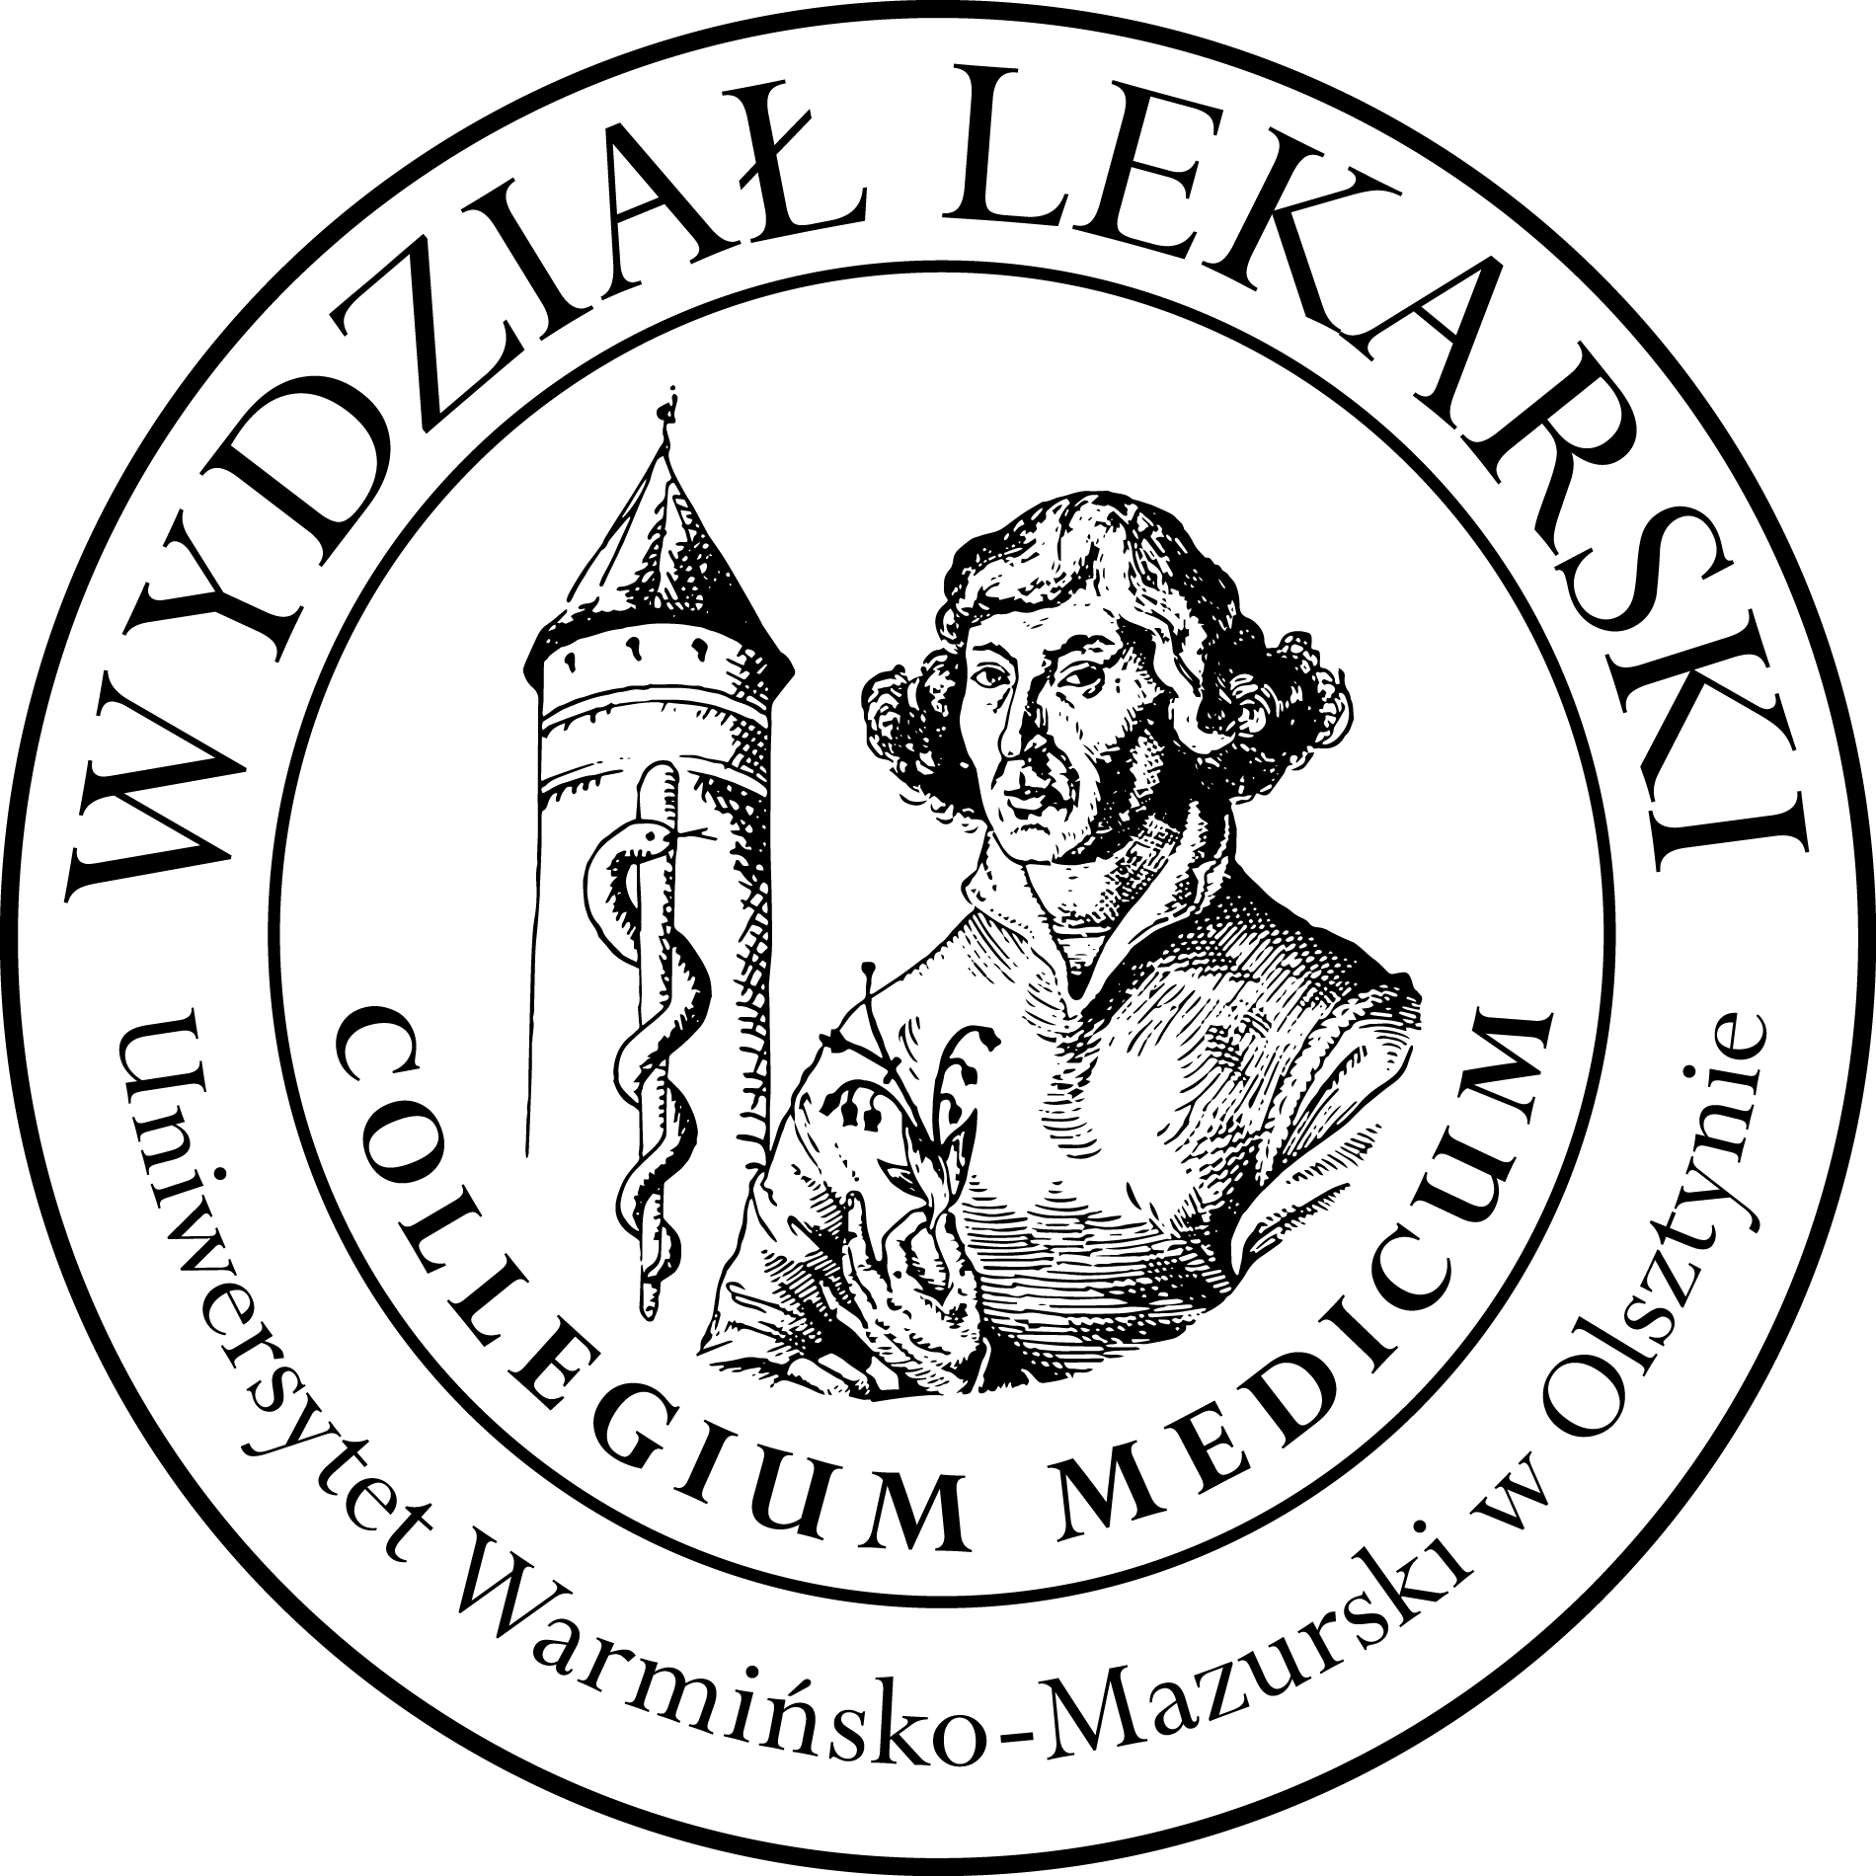

**UNIVERSITY OF WARMIA AND MASURIA**

in Olsztyn

**COLLEGIUM MEDICUM**

**FACULTY OF MEDICINE**

Warszawska 30, 10-082 Olsztyn, Poland

Tel.: +48 89 524 61 01∙ Fax.: +48 89 524 61 14

E-mail: medicine.info@uwm.edu.pl

studyingmedicine@gmail.com

**Clinical Skills**

**3 year ED – Winter - 2024/2025**

**Classes (9h)-x 3gr=27h ----------------------------------------------------------------------------------------------------------------**

***Coordinator : dr n. med. Beata Moczulska***

***lek. med. Patryk Zastawny***

|  |  |  |  |
| --- | --- | --- | --- |
| ***Group*** | ***Date*** | ***Time*** | ***Room*** |
| ***1*** | ***26.11.24*** | ***10.00-12.15*** | ***CSM 106*** |
| ***03.12.24*** |
| ***10.12.24*** |
|  | | |
| ***2*** | ***14.10.24*** | ***10.00-12.15*** | ***CSM 106*** |
| ***21.10.24*** |
| ***28.10.24*** |
|  | | |
| ***3*** | ***15.10.24*** | ***10.00-12.15*** | ***CSM 106*** |
| ***05.11.24*** |
| ***19.11.24*** |
|  | | |