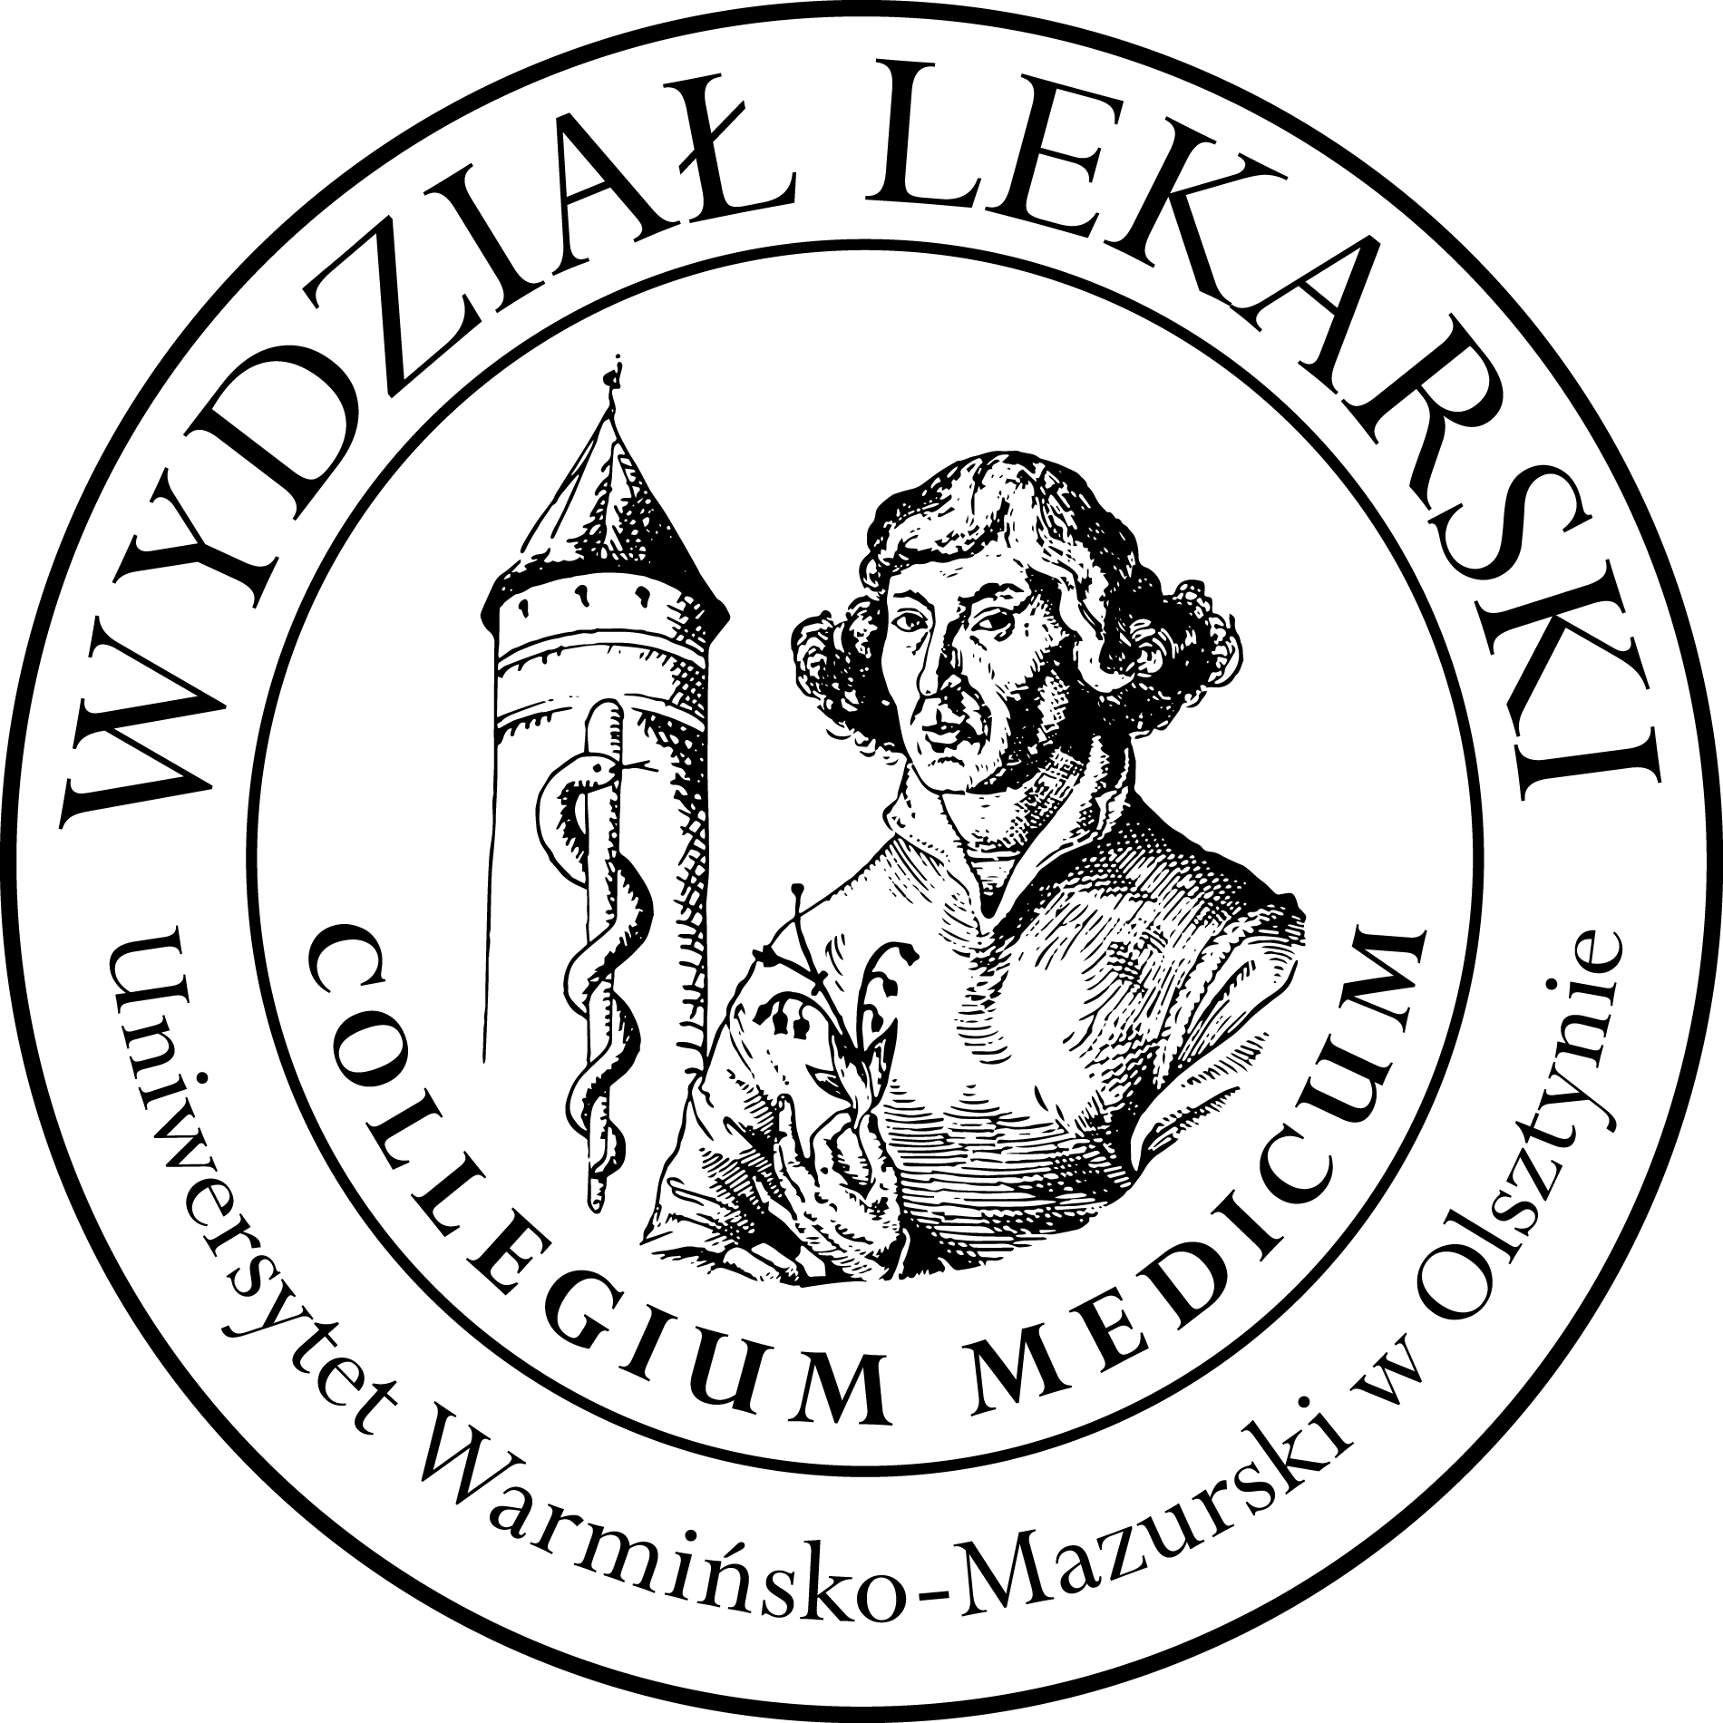

UNIVERSITY OF WARMIA AND MASURIA
in Olsztyn
COLLEGIUM MEDICUM
FACULTY OF MEDICINE
Warszawska 30, 10-082 Olsztyn, Poland
Tel.: +48 89 524 53 89∙ Fax.: +48 89 524 53 89
E-mail: barbara.neumann@uwm.edu.pl
studyingmedicine@gmail.com

Schedules Nuclear Medicine III ED 2023/2024
Prof. Jarosław Ćwikła MD,PhD

Lectures:
28.02, 06.03; 13.03; 20.03.24 hour 13.30 -15.00 Library, room 116

03.04.24 hour 15.45-17.15 Library, room 116

Classes :
Gr 1
12.06.24 hour 13.30-15.30 Library, room 116
24.04.24 hour 17.30-19.30 CSM 106
Gr 2
12.06.24 hour 9.00-11.00 Library, room 116
15.05.24 hour 17.30-19.30 CSM 106
Gr 3
10.04.24 hour 18.00-20.00 Library, room 104

12.06.24 hour 11.15-13.15 Library, room 116

