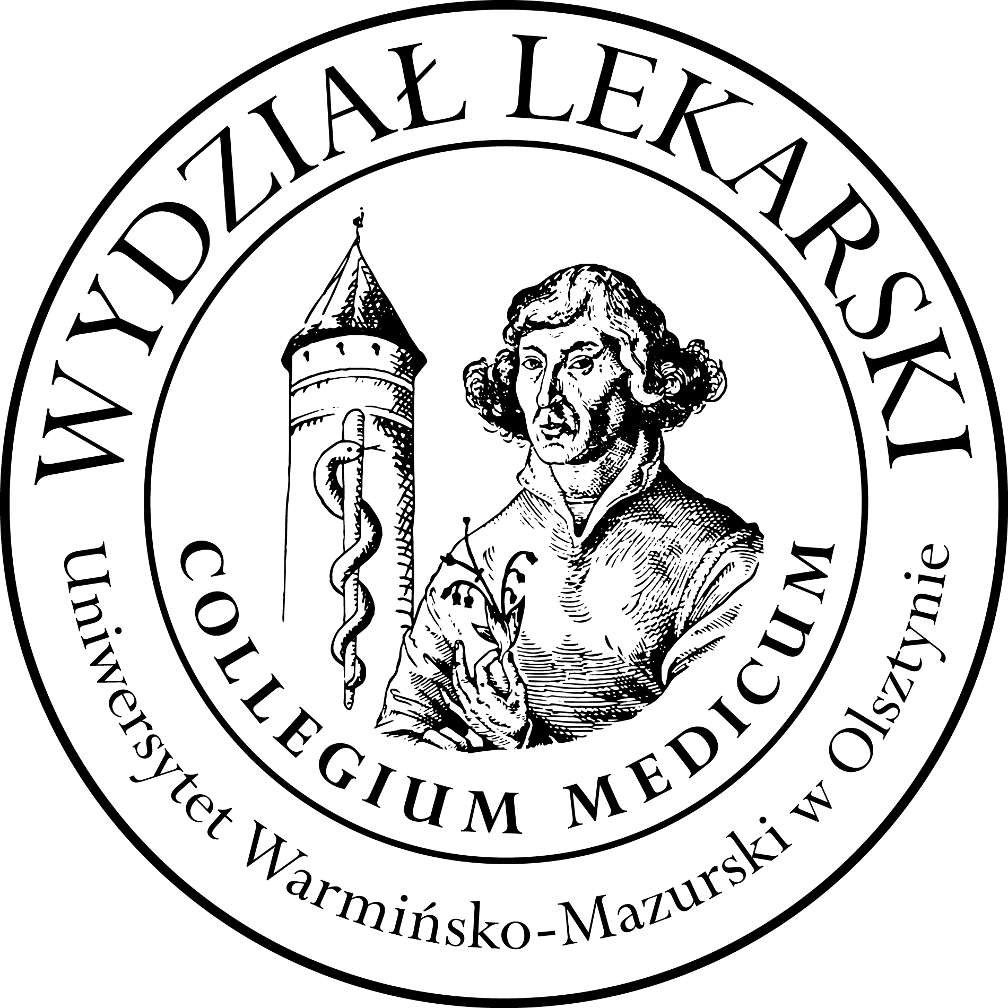

UNIVERSITY OF WARMIA AND MASURIA
in Olsztyn
COLLEGIUM MEDICUM
FACULTY OF MEDICINE
Warszawska 30, 10-082 Olsztyn, Poland
Tel.: +48 89 524 61 01∙ Fax.: +48 89 524 61 14
E-mail: medicine.info@uwm.edu.pl
studyingmedicine@gmail.com

PBL ( Problem Based Learning)
3 year ED – Summer - 2023/2024

Classes (20h) x3 groups =60h -------------------------------------------------------------------------------------------------------------------------------------
Course Coordinator dr n. med. Beata Moczulska ( BM)

Group | Date | Time | Room
1  (BM) | 19.03.24 | 12.00-13.30 | Department of Internal Medicine, Conference Room USK Hospital  (next to the emergency room)  floor 3
 | 26.03.24 | 12.00-14.15
 | 05.04.24 | 13.00-14.30
 | 07.05.24 | 12.00-14.15
 | 28.05.24 | 12.00-13.30
 | 07.06.24 | 12.30-14.45
 | 11.06.24 | 12.00-13.30
 | 14.06.24 | 12.30-14.45
2  (PZ) | 20.02.24 | 12.00-13.30
 | 27.02.24 | 12.00-14.15
 | (BM) 08.03.24 | 13.30-15.00
 | 22.03.24 | 12.00-14.15
 | 16.04.24 | 12.00-13.30
 | 14.05.24 | 12.00-14.00
 | 17.05.24 | 14.15-15.45
 | 04.06.24 | 12.00-14.15
3  (BM) | 05.03.24 | 12.00-13.30
 | 12.03.24 | 12.00-14.15
 | (PZ) 19.03.24 | 13.45-15.15
 | 19.04.24 | 13.00-14.30
 | 23.04.24 | 12.00-13.30
 | 14.05.24 | 14.30-16.45
 | 21.05.24 | 12.00-13.30
 | 04.06.24 | 14.30-16.45

