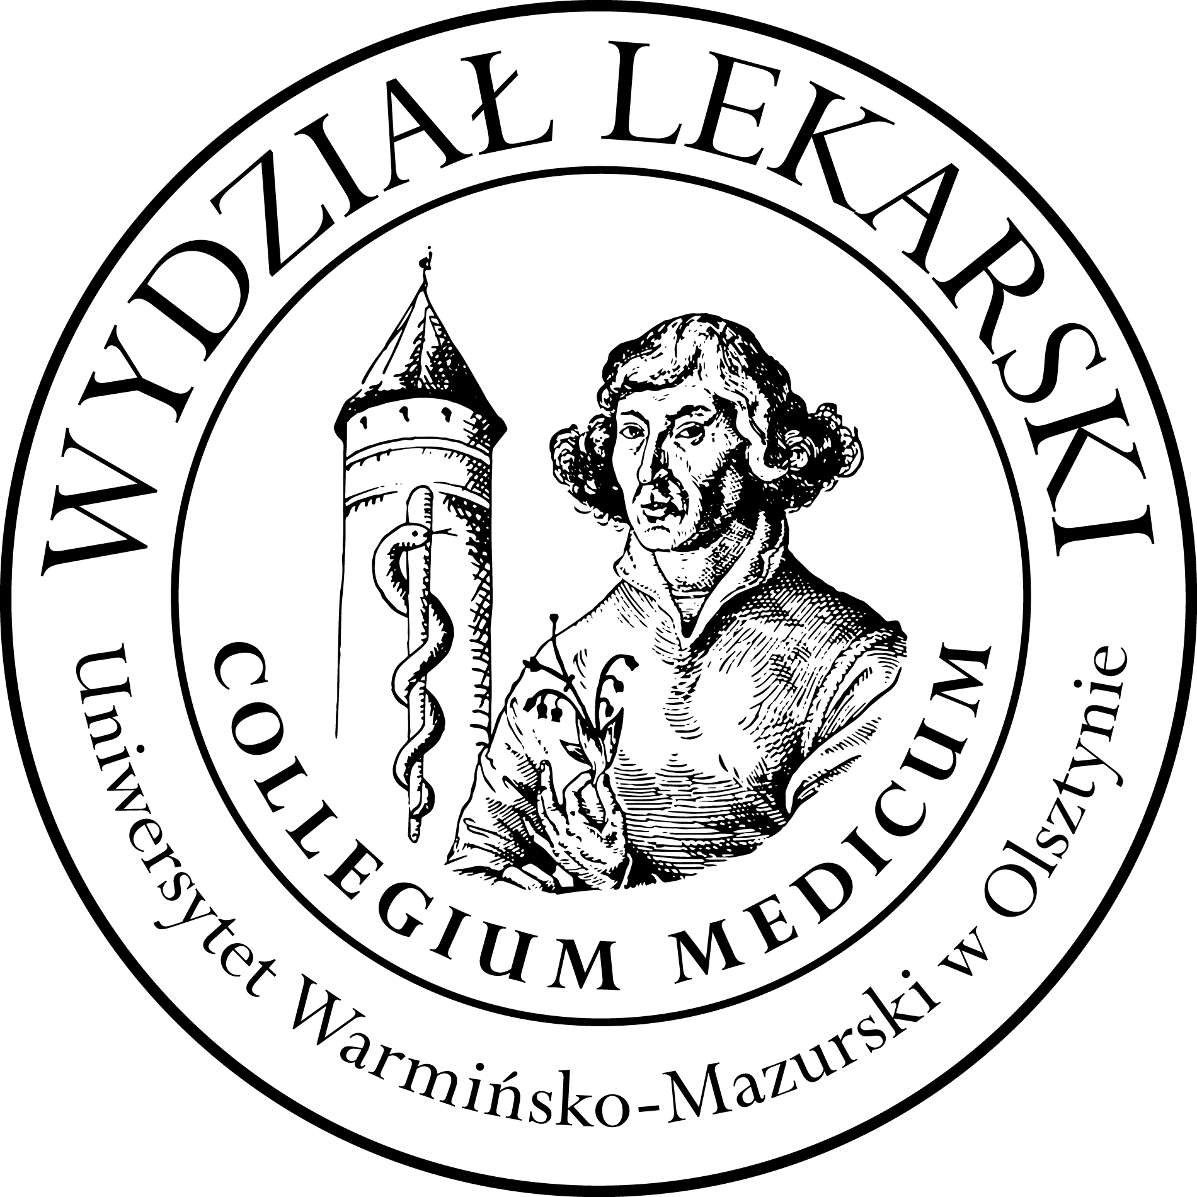

UNIVERSITY OF WARMIA AND MASURIA
in Olsztyn
COLLEGIUM MEDICUM
FACULTY OF MEDICINE
Warszawska 30, 10-082 Olsztyn, Poland
Tel.: +48 89 524 61 01∙ Fax.: +48 89 524 61 14
E-mail: medicine.info@uwm.edu.pl

studyingmedicine@gmail.com

Clinical skills
2 year ED – Summer - 2023/2024
Coordinator Beata Moczulska MD PhD
Teatcher : Sylwia Leśniewska MD

Classes (14h) x 3 groups= 42 h x 3 = 126h

Group | Date | Time | Room
Gr. 1 | 22.02.24 | 18.00-20.15 | CSM 202
 | 29.02.24 | 18.00-20.15 | CSM 202
 | 07.03.24 | 18.00-20.15 | CSM 106
 | 15.03.24 | 16.00-19.30 | CSM 206
Gr. 2 | 19.03.24 | 16.15-18.30 | CSM 202
 | 26.03.24 | 16.15-18.30 | CSM 202
 | 09.04.24 | 16.15-18.30 | CSM 202
 | 16.04.24 | 16.15-19.15 | CSM 106
Gr.3 | 22.02.24 | 15.30-17.45 | CSM 202
 | 29.02.24 | 15.30-17.45 | CSM 202
 | 07.03.24 | 15.30-17.45 | CSM 106
 | 14.03.24 | 15.30-18.30 | CSM 106

