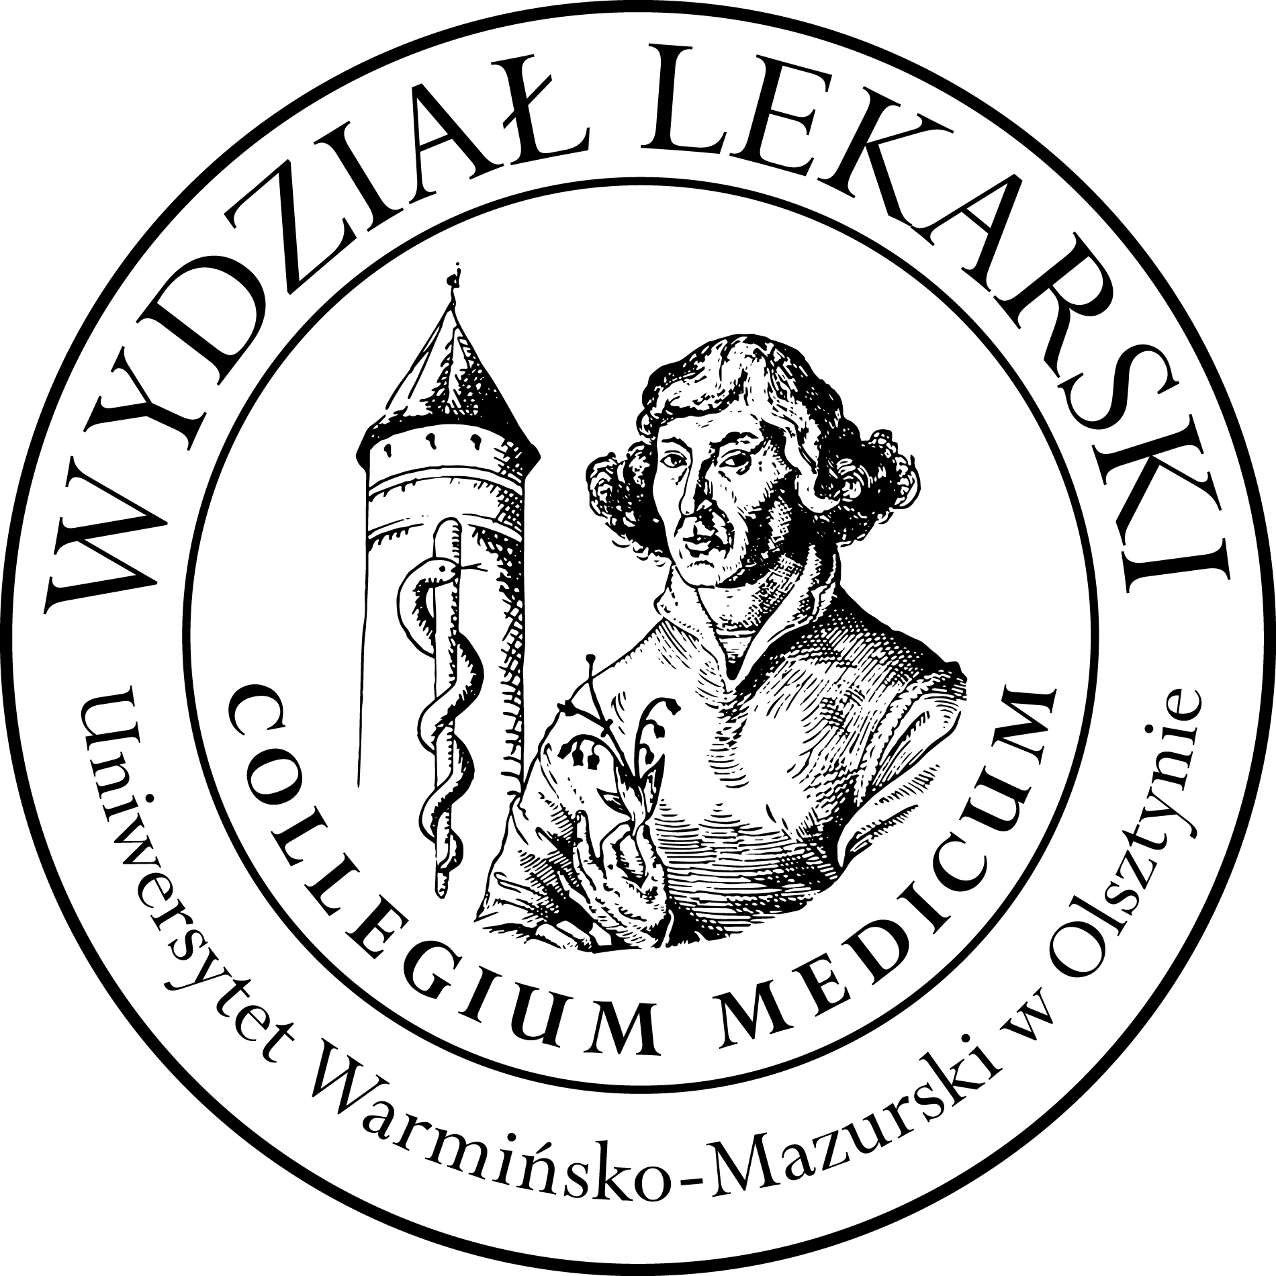

UNIVERSITY OF WARMIA AND MASURIA
in Olsztyn
COLLEGIUM MEDICUM
FACULTY OF MEDICINE
Warszawska 30, 10-082 Olsztyn, Poland
Tel.: +48 89 524 61 01∙ Fax.: +48 89 524 61 14
E-mail: medicine.info@uwm.edu.pl
studyingmedicine@gmail.com

Clinical Skills
3 year ED – Winter - 2023/2024

Classes (9h)-x 3gr=27h x 3=81 h----------------------------------------------------------------------------------------------------------------
lek. med. Sylwia Leśniewska

Group | Date | Time | Room
1 | 04.10.23 | 13.00-15.15 | CSM s. 106
 | 12.10.23 | 13.00-15.15 | CSM s. 106/ Emergency room CSM
 | 07.11.23 | 15.30-17.45 | CSM s. 204
2 | 11.10.23 | 13.00-15.15 | CSM s. 106
 | 17.10.23 | 13.00-15.15 | CSM s. 106
 | 24.10.23 | 13.00-15.15 | CSM s. 106/ Emergency room CSM
3 | 12.10.23 | 10.30-12.45 | CSM s. 106
 | 07.11.23 | 13.00-15.15 | CSM s. 106
 | 15.11.23 | 15.30-17.45 | CSM s. 106/ Emergency room CSM

